**Sprint Planning project Template**

|  |  |
| --- | --- |
| Date | 30 June 2025 |
| Team ID | LTVIP2025TMID29114 |
| Project Name | Sustainable Smartcity Assistant Using IBM Granite LLM |
| Maximum Marks |  |

**Use the below template to create product backlog and sprint schedule**

|  |  |  |  |  |  |  |
| --- | --- | --- | --- | --- | --- | --- |
| Sprint | Functional Requirement (Epic) | User Story Number | User Story / Task | Story Points | Priority | Team Members |
| Sprint-1 | User Authentication | USN-1 | As a user, I can register using email and password | 2 | High | Vasantha Lakshmi |
| Sprint-1 | User Authentication | USN-2 | As a user, I can login using email and password | 1 | High | Abhishek |
| Sprint-1 | User Authentication (OAuth) | USN-3 | As a user, I can login/register using Google OAuth | 3 | High | Akshai |
| Sprint-1 | Role Management | USN-4 | After login, I can select role as 'Citizen' or 'Administrator' | 2 | Medium | Bangarraju |
| Sprint-2 | Policy Summarization | USN-5 | As a user, I can upload a policy document and receive a summary via AI | 3 | High | Vasantha Lakshmi |
| Sprint-2 | Citizen Feedback | USN-6 | As a citizen, I can submit feedback or complaints through a form | 2 | Medium | Akshai |
| Sprint-2 | Feedback Analysis | USN-7 | As an admin, I can view analyzed citizen feedback with sentiment classification | 3 | High | Abhishek |
| Sprint-3 | Eco Tips Generator | USN-8 | As a citizen, I can receive daily eco tips personalized to my role or location | 2 | Medium | Bangarraju |
| Sprint-3 | KPI Forecasting | USN-9 | As an admin, I can view KPI forecasts using visual charts and graphs | 3 | High | Akshai |
| Sprint-3 | Data Visualization | USN-10 | As an admin, I can track trends using real-time KPI visualizations | 2 | Medium | Vasantha Lakshmi |
| Sprint-4 | Anomaly Detection | USN-11 | As an admin, I can receive alerts for unusual activity in city data (e.g., traffic, energy usage) | 3 | High | Abhishek |
| Sprint-4 | Admin Dashboard | USN-12 | As an administrator, I can manage citizen feedback, view KPIs, and summarize policy insights | 3 | High | Bangarraju |
| Sprint-5 | AI Chat Assistant | USN-13 | As a user, I can ask city-related queries via a natural language interface | 3 | High | Akshai |
| Sprint-5 | Chat Backend Integration | USN-14 | As a developer, I can connect the chat UI to backend services (Granite, Pinecone) | 3 | High | Vasantha Lakshmi |
| Sprint-5 | Error Handling & Routing | USN-15 | As a user, I can be redirected to correct modules based on role and get appropriate error messages | 2 | Medium | Abhishek |
|  |  |  |  |  |  |  |

Project Tracker, Velocity & Burndown Chart (4 Marks)

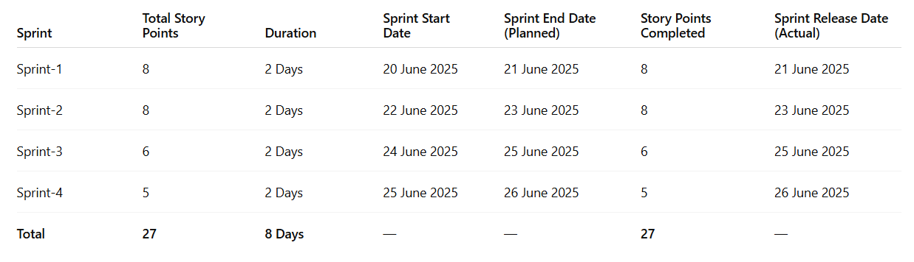

**Velocity**

**Team Average Velocity (AV):**  
✅ 22 story points over 3 completed sprints (6 days)  
✅ **AV = 22 ÷ 6 = ~3.66 story points/day**